Screen Form Design

**Form Mockup:**

**Using Draw.io (see Tutorial for Draw.io)**

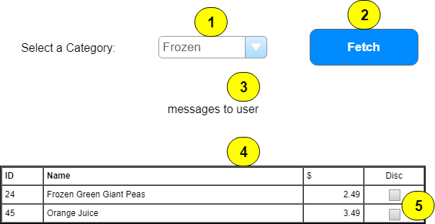

|  |  |  |  |  |  |
| --- | --- | --- | --- | --- | --- |
|  | **Control Name** | **Load/Pos** | **CRUD** | **Validation** | **Event Actions / Notes** |
| 1 | CategoryList |  | R |  | * Page_Load (!IsPostBack) * BLL: CategoryController * List<Category> Categories_List() * Standard lookup * Sort list * Add prompt line * Code in separate method |
| 2 | Fetch | 4 | R | CausesValidation F | * Require Categorylist selection * Will fill GridView with queried data * BLL: ProductController * List<Product> Products_FindByCategory(int) * Standard lookup |
| 3 | MessageLabel | 2 |  |  | * Used to display messages * Empty in Page_Load |
| 4 | ProductList | 2 | R |  | * Customize for specific fields * CheckBox for Discontinued * Sort data by Product Name * Use Templates for columns |
| 5 | Discontinued |  |  |  | * Enable false |